Effect of Image Contrast on Information-Theoretic Features
using Histogram-Based and Correlative Measures
Sarah Mahdi Baqer ¹, Zahir M. Hussain ^{2,3}
¹ MSc Candidate, Faculty of Computer Science and Math, University of Kufa, Najaf, Iraq
² Faculty of Computer Science and Math, University of Kufa, Najaf, Iraq
³ Professor (Adjunct), School of Engineering, ECU, Australia

ABSTRACT
Development of a suitable quantitative measure is considered an important step in image enhancement.
Considering the accuracy requirement in decision supports، quantitative measure must accord with human perception and subjective analysis should match with objective evaluation value. Unfortunately, existing Image Quality Assessment techniques cannot sufficiently represent the visual quality of enhanced image. In this work we investigate information-theoretic consequences of image contrast enhancement. This is a step towards defining a quantitative measure for contrast enhancement. The main information-theoretic features in this context are the Shannon and Renyi entropies for different joint and relative histogram-based and correlative measures. The proposed measures have been tested for different enhanced image under Gaussian noise for different PSNR. The visual results show that relative joint histogram and correlative measures are more descriptive at high/low PSNR.
Keywords: Histogram-Based contrast enhancement،symmetric joint histogram, Shannon and Renyi entropies، correlative measures

INTRODUCTION
Image contrast enhancement is considered as one of the momentous techniques in digital image processing. Image quality may be affected by many factors such as illumination conditions, random noises or quality of image capturing devices. Various enhancement techniques can be applied to ameliorate image quality and perception of information within image.
So far، many traditional techniques such as histogram equalization(HE), logarithmic transformation, gamma correction have been implemented to improve image contrast by improving the dynamic rang of the resultant image. [1-5]
Despite a number of image enhancement techniques are available, development of a quantitative measure appropriate for all kinds of image is still problem.
Considering the accuracy requirement in decision supports, improvement of visual quality of image is subjective matter since it could vary from one person to another, but for many applications such as medical image processing it become a time-consuming process. so the quantitative measure will be more and more important in evaluating the effect of image enhancement in a manner in accord with human perception and subjective analysis should match with objective evaluation value.
To define a quantitative measure for contrast enhancement it has become imperative to investigate the effect of contrast enhancement on information theoretic features.
In this work, concepts of Shannon and Renyi entropies are used for different joint and relative histogram-based and correlation measures.

HISTOGRAM-BASED CONTRAST ENHANCEMENT
Low contrast image have large number of pixels that occupy small portion of the available range of intensities. we can increase dynamic range of gray level by means of histogram modification, whereas the dynamic range of image is stretched in manner that darker pixels remain dark while the lighter pixels will be still lighter.
By studying the histogram of image we can provide fundamental information about contrast, so we first discuss the image histogram then we discuss effect of image contrast using Shannon and Renyi entropies.
2.1 Image Histogram
Histogram is graphical representation of the brightness distribution of digital image، showing the relative frequency of occurrence of different gray levels in the image. The histogram gives primary description of the image. For low contrast image, the histogram will be narrow, but if the histogram have equal spread in the gray level, this means that the overall contrast increase.
The normalized histogram of digital image with gray level in the range [0, L-1] is given by:

$h\left( r_{k}\right)=\frac{n_{k}}{N} ; k=0,1,⋯,L-1 (1)$
Where $h(r_{k})$ gives an estimate of the probability occurrence of gray level $r_{k}$, $r_{k}$ is the $k^{\text{th}}$ gray level, and $n_{k}$ is the number of pixels in the image with gray level, N is total number of image pixels.

2.2 Symmetric Joint Histogram
In our work we implement the concept of symmetric joint histogram which has defined as:
$$T_{ij }\left(x,x\right)= T_{ji } (x,x)$$

and

$$T_{i+1,j+1 }= T_{i+1,j+1 }+1 (2)$$

2.3 Entropy and image contrast
One measure that is being used for quantifying information is the Shannon-wiener
entropy measure.
The entropy H of discrete random variable X is defined by(Shannon and weaver, 1967) as:

$H\left(X\right)=-\sum_{i=1}^{n}{p_{i}}\log_{2}{(p_{i})} (3)$
where:
$$p_{i}= P[X=x_{i }]$$

One of many types of entropy is Renyi entropy that has been defined by (Renyi،1961) as:

$H_{α }\left(X\right)=\frac{1}{1-α}\log_{2}{\sum_{i=1}^{n}{{p_{i}}^{α } (4)}}$

Where, α ≥ 0 and α≠ 0 is positive real parameter.
In[6-7], entropy is used as measure for enhanced image, showing that enhanced image has higher entropy than original image, without explaining the exact relationship between entropy and image information-content, because subjective evaluation of different kinds of images showed that there could be inconsistency between visual appearance of the proposed image and high contrast value.
The concept of joint entropy can be viewed using joint probability distribution calculated from two different images as follow (viola and wells, 1995):

$$H\left(X,Y\right)=-\sum_{i=1}^{n}{\sum_{j=1}^{m}{p_{ij }}}\log{{ p}_{ij}} (5)$$

The joint entropy represent uncertainty in joint histogram outcomes، when the uncertainty in the outcomes is highest (joint outcomes are independent), the resultant entropy will be highest.
For aligned images there exist a linear relationship in the joint histogram, but it becomes dispersed during image misalignment.

PROPOSED MEASURES FOR CONTRAST-INFORMATION RELATIONSHIP
The performance of proposed contrast-information measures have been tested for different enhanced image. Our proposed measures include relative covariance entropy measure which has been defined as:

$$E\left(X,Y\right)=H\left[\frac{cov(T_{ij}-T_{ii })}{cov(T_{ii }+d)}\right] (6)$$

Where H is Shannon or Renyi entropies as per equation 1 and 2،$T_{ij}$ is joint histogram of original and enhanced image with Gaussian noise, d is very small positive constant, inserted to avoid division by zero.
Another our proposed measure is the entropy of relative histogram between original and enhanced image as follow:

$$E\left(X,Y\right)=H\left[\frac{h_{i}}{h_{j}+d}\right] (7)$$

Where, H is Shannon or Renyi entropies as per equation 1 and 2, $h_{i}$is histogram of original image, $h_{j }$is histogram of enhanced image, d is very small positive constant, inserted to avoid division by zero.
Variations in image contrast are derived by using contrast stretch image enhancement technique as follow:

$$F\left(x\right)=\frac{1}{1 + (\frac{b}{x} )^{p}} (8)$$
P: different contrast parameter, larger p gives stronger contrast.
since optimal enhanced image is not known a-priori for image enhancement, so our proposed measures have been implemented for different contrast parameter(p). we also test our proposed measures under Gaussian noise which is the basic source of noise in many image processing systems
for different PSNR.

RESULTS AND DISCUSSIONS
After we implemented the enhancement technique as per equation 8, we tested the performance of our measures as per equation 6 and 7 under noisy condition, when it has been corrupted with Gaussian noise for different PSNR.
The visual results of our study clearly indicate that our contrast measure of the original and enhanced image under Gaussian noise reach its maximum value (global peak) at specific contrast parameter value.
Figure 1 show the performance of the proposed measures for images under Gaussian noise:

CONCLUSION
A new contrast-information measures have been proposed and tested for enhanced image under Gaussian noise. Our proposed measures are based on histogram and correlative measure for different Shannon and Renyi entropies. It has been shown that proposed measures reach its global peak at particular contrast parameter value. Our study in this work is considered as step toward defining a quantitative measure for contrast enhancement in future works.
6. REFERENCES
R. Maini and H. Aggarwal, "A Comprehensive Review of Image Enhancement Techniques," Journal of Computing, V. 2, N. 3, 2010.
M. R. Tarambale, N. S. Lingayat, "﻿Spatial Domain Enhancement Techniques for Detection of Lung Tumor from Chest X-Ray Image," International Journal of Application or Innovation in Engineering & Management, V. 2, N. 8, 2013.
S. O. Mundhad, “spatial and transformation domain techniques for image enhancement,” International Journal of Engineering Science and Innovative Technology, V.1،N.2، 2012
Brindha, Bharathi, Anusuya, Praiseline Karunya, “Image Enhancement Techniques: A Review,” International Journal of Research in Engineering and Technology, V.4,N.5, 2015.
N. Sazonova, S. Schuckers, “Fast and efficient iris image enhancement using logarithmic image processing,” SPIE Proceedings, Volume 7667, 2010.
Y. Zhengmao, H. Mohamadian, Y. Yongmao, ”analyzing contrast enhancement and watershed segmentation using quantitative information measuring,” proceedings of the 17th world congress on intelligent control and automation, June 25 - 27, 2008 IEEE, Chongqing, pp:248-253.DOI: 10.1109/WCICA.2008.4592932
Y. Zhengmao, H. Mohamadian, H. Majlesein, “Adaptive Enhancement of Graylevel and True Color Images with Quantitative Measurement Using Enropy and Relative Entropy ” 40th southeastern symposium on system theory، March 16-18,2008 IEEE، New Orleans،LA, PP:127-131.DOI: 10.1109/SSST.2008.4480204
Z. M. Hussain, An Introduction to Digital Image Processing, University of Kufa Press, 2014.
A. F. Hassan, D. Cai-lin, Z. M. Hussain, “An Information-Theoretic Image Quality Measure: Comparison with Statistical Similarity,” Journal of Computer Science, v.10, no. 11, pp.2269-2283, 2014.
A. Rényi, "On Measures of Entropy and Information," Proc. Fourth Berkeley Symp. Math. Stat. and Probability, Vol. 1. Berkeley, CA: University of California Press, (1961) pp. 547-561.
G. Deng, L. W. Cahill, and G. R. Tobin, "A study of the logarithmic image processing model and its application to image enhancement," IEEE Trans. Image Process., Vol. IP-4, pp. 506- 512, 1995.
A. F. Hassan, D. Cai-lin, Z. M. Hussain,” An Information Theoretic Measure for Face Recognition:Comparison with Structural Similarity,” International Journal of Advanced Research In Artificial Intelligence, Vol. 3. no. 11, 2014

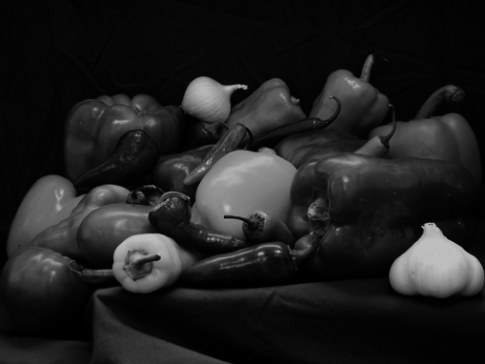

(a)
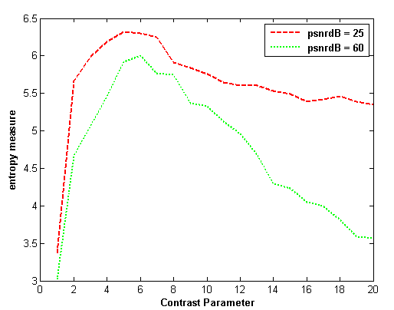
(b)
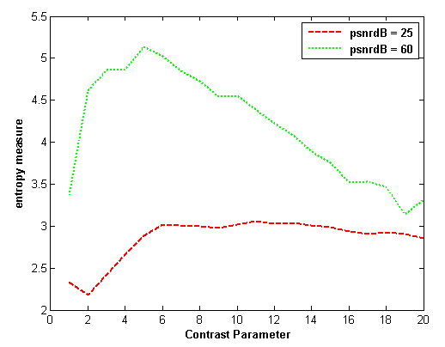
(c)
Fig 1. Performance of the proposed measures using matlab image under Gaussian noise, (a)the test image، (b)relative histogram entropy measure (c) covariance entropy measure.

